ADVANCED (and leftover) FEATURE CHECKLIST FOR TALES OF BUZZ

Student Name: Mythri Muralikannan

ADVANCED FEATURES (choose up to 10):

YES Add a start page. Must include options to view controls, start game, and the name of your game

____ Sound effects for interactions / background music

YES Different modes of locomotion (e.g., running, hopping, etc.) They should be visually distinctive.

YES Animation for interactions with static things in the map

.... In-game menu (each counts as separate feature):

____ Save the game

____ Show status information

____ Other (Please describe)

YES In game inventory with useable items

Multiple lives and the possibility to lose:

YES Health & stuff that hurts you.

____ Other (Please describe)

____ Mobile (walking) NPCs or wizards/monsters

____ Save the game (persistent over power-off) - will require the use of the SD card reader.

.... Bigger objects in the map that blocks the character.

YES A very tall tree that hides the character.

____ A feature you can walk behind/under, such as a bridge.

____ Other (Please describe)

____ Multiple bosses to defeat with distinct attacks/spells

.... Animation with non-static things in map (e.g.: throwable combat items)

____ Animated dagger/spells

____ Others (Please describe)

____ Side quests

____ Enemies have health bars and take multiple hits to defeat

____ Player levels up / Unlocks additional abilities

____ Cut scene in the game

… Others: (Please describe) - Note.: Needs approval on Ed Discussion

YES 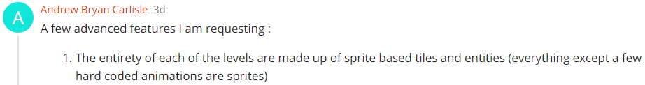

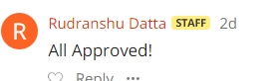

YES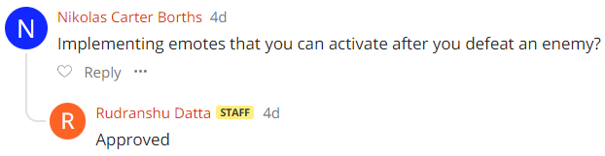

YES 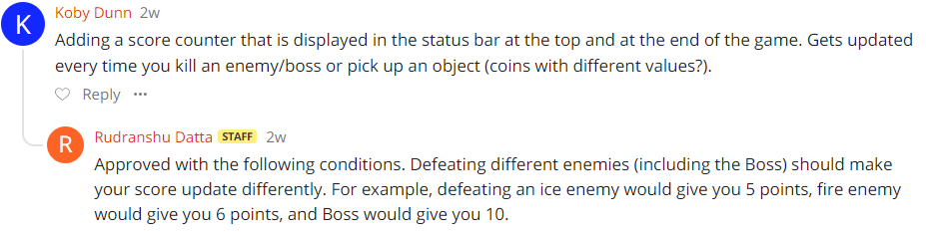

YES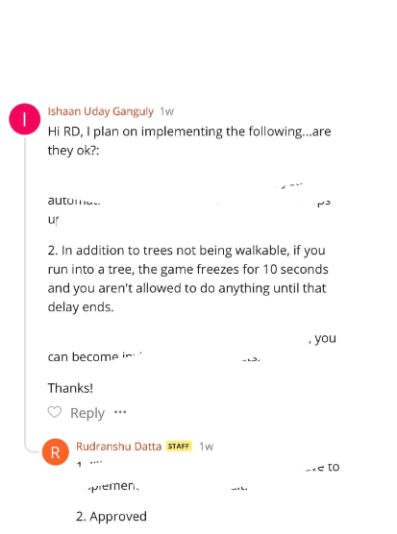

LEFTOVER BASE FEATURES

(check only leftover base features you finished since submitting your P2-2 Baseline)

____ Nav-Switch moves the player

____ Walls block character motion

____ The first Map must be bigger than the screen (at least 50*50 tiles)

____ Stairs/ladders/portals/door to go between the first and the second map.

____ More than one (1) attack to choose from to fight enemies/bosses

____ Quest works (key & door work)

____ Display Game Over when quest is completed

____ Speech bubbles used in quest and casting spell

____ Art include at least one (1) sprite

____ Enemies drop items when defeated